Overview
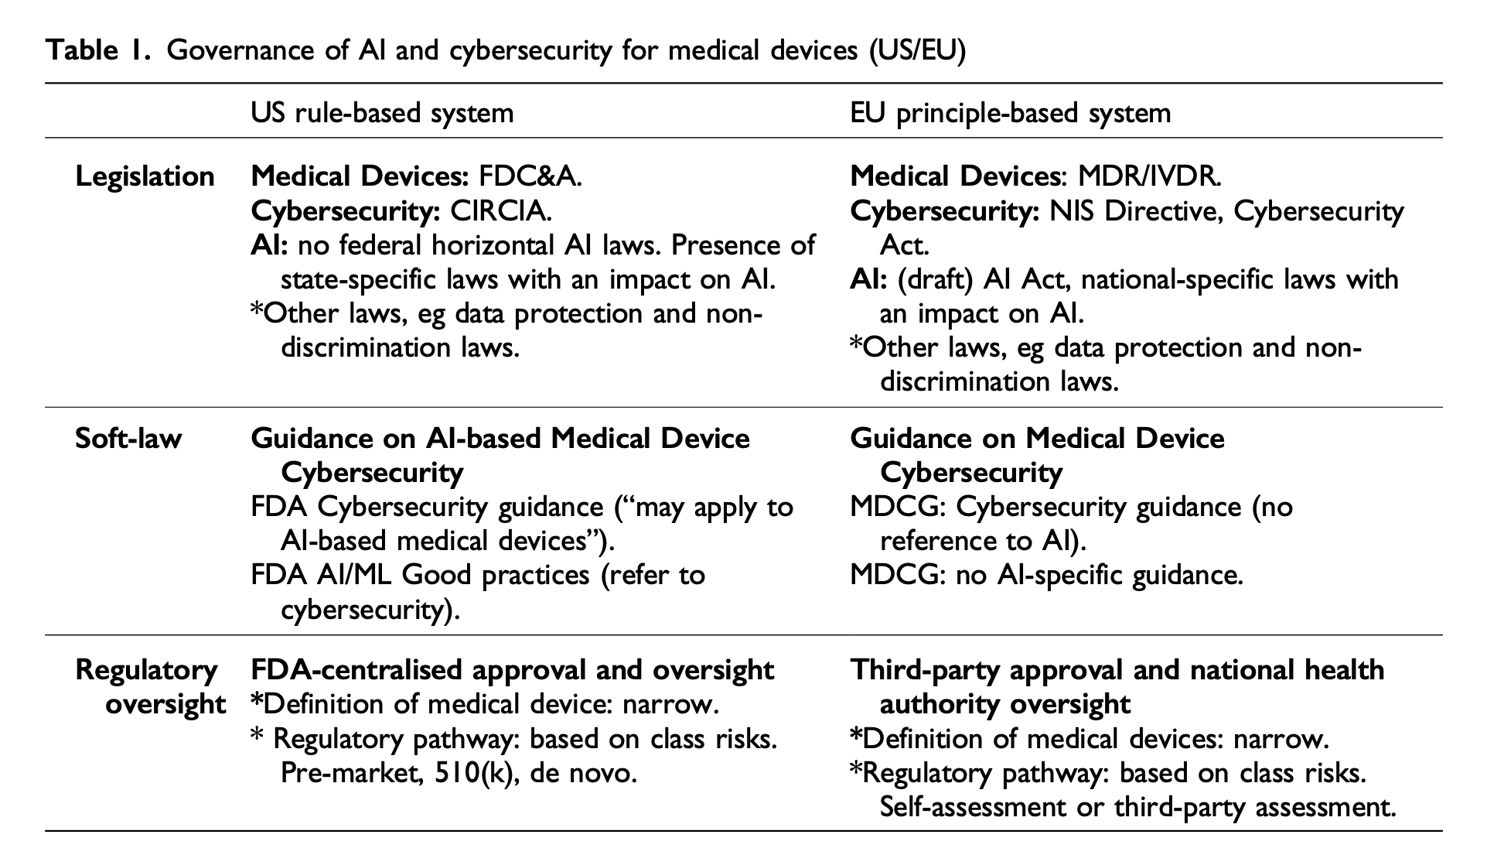

1. Context and Scope
Cybersecurity in AI-Based Medical Devices:
Problem: AI-based medical devices (e.g., insulin pumps, imaging systems) face rising cybersecurity threats, such as ransomware attacks (e.g., WannaCry), which disrupt healthcare and endanger patient safety.
Challenges:
- Evolving technology (AI, machine learning) creates unique vulnerabilities.
- Current frameworks inadequately address lifecycle risks like data poisoning or outdated software updates.
Goal: Strengthen regulatory approaches to ensure AI-based devices remain safe and secure while fostering innovation.

2. Hard Law vs Soft Law in Regulatory Frameworks
Hard Law:
Binding legal instruments, such as directives, regulations, and statutes. Examples:
EU:
1. Medical Device Regulation (MDR) and In Vitro Diagnostic Regulation (IVDR):
- Set binding safety and performance standards for devices.
- Include cybersecurity requirements (e.g., Annex I demands risk management, state-of-the-art IT security).
2. NIS2 Directive: Imposes risk management and incident reporting obligations on critical healthcare infrastructure, including device manufacturers.
3. Draft AI Act: Horizontal legislation classifying high-risk AI systems (including AI-based medical devices) with additional safety and cybersecurity measures.
4. Cybersecurity Act: Establishes voluntary certification schemes for device manufacturers.
US:
1. Food, Drug, and Cosmetic Act (FD&C Act):
- Section 360n–2 specifies mandatory cybersecurity measures for devices.
2. CIRCIA (2022): Requires incident reporting for critical infrastructure, indirectly covering medical devices.
Soft Law:
Non-binding guidelines and recommendations. Examples:
EU:
MDCG Cybersecurity Guidance (2019): Explains how MDR/IVDR safety requirements apply to cybersecurity but does not address AI-specific challenges.
US:
1. FDA Cybersecurity Guidance (2005–2023): Continuous updates on cybersecurity best practices (e.g., pre-market submissions, post-market surveillance).
2. FDA AI/ML Action Plan (2021): Details regulatory approaches for AI-based software as a medical device (SaMD), emphasizing security.

3. EU Legal Framework
Medical Device Regulation (MDR) and In Vitro Diagnostic Regulation (IVDR):
- Central hard laws regulating device safety and performance.
- Include cybersecurity as part of safety obligations, requiring manufacturers to:
1. Manage cybersecurity risks throughout the lifecycle.
2. Implement state-of-the-art IT security measures (Annex I).
- Flexible, principle-based rules allow adaptation to evolving technology.
Draft AI Act:
1. Introduces obligations for high-risk AI systems, including:
- Risk management and accountability for AI developers.
- Security measures to prevent manipulation or misuse.
2. Devices certified under the Cybersecurity Act benefit from presumptions of conformity.
NIS2 Directive:
1. Focuses on critical infrastructure, including healthcare.
2. Requires device manufacturers to:
- Report cyber incidents within 24 hours.
- Implement robust cybersecurity risk management.
Key Gaps:
1. Limited AI-specific guidance (e.g., no MDCG equivalent to FDA AI/ML frameworks).
2. Decentralized oversight by notified bodies limits consistency in cybersecurity enforcement.

4. US Legal Framework
1. Food, Drug, and Cosmetic Act (FD&C Act):
1. Governs medical device safety through risk-based classification:
Class I: Low risk (e.g., bandages).
Class II: Moderate risk (e.g., X-ray machines).
Class III: High risk (e.g., pacemakers).
2. Section 360n–2 mandates device-specific cybersecurity standards, including:
- Risk management plans.
- Post-market vulnerability disclosures.
2. 510(k) Pathway:
The 510(k) pathway—which may apply to class I, II, and III medical devices for which pre-market approval is not indicated—allows the evaluation procedure to be based on comparing a device to one or more similar legally marketed devices (predicate device).
Criticism:
- Security of former devices is likely to have different and lower cybersecurity standards, this may lower security standards for AI-based medical devices.
3. CIRCIA:
- Imposes incident reporting requirements for cyber incidents for critical infrastructure.
Key Strengths:
- FDA’s centralised approval ensures uniform oversight across all states.
- Frequent updates to FDA guidance adapt quickly to emerging threats.

5. Comparative Analysis
Regulatory Approach:
EU:
Principle-Based:
- Broad principles focus on safety, flexibility, and technology neutrality.
- Specificity delegated to harmonized standards and notified bodies.
- Limited cybersecurity and AI-specific guidance.
US:
Rule-Based:
- Detailed, prescriptive rules issued by the FDA.
- Continuous updates ensure alignment with technological advances.
Oversight:
EU:
1. Decentralized: Notified bodies and national health authorities share oversight.
2. Risk: Fragmented enforcement undermines consistency.
US:
1. Centralized: FDA oversees compliance throughout the device lifecycle.
2. Strength: Continuous post-market monitoring ensures real-time adjustments.
AI Governance:
EU:
- Draft AI Act creates the first horizontal AI regulation globally.
Gaps: No sector-specific pathways for AI-based medical devices.
US:
- Executive orders provide AI safety and security guidance but lack binding federal laws.
Gaps: AI governance heavily relies on FDA interpretation.

A predicate device is a medical device that is legally marketed in the United States and is used as a point of comparison for new medical devices seeking FDA approval.

